**Dataset Description:**

|  |  |
| --- | --- |
| **Dataset** | **Dataset Description** |
| model_id | A unique identifier for each mobile phone model. |
| model | The name or model number of the mobile phone. |
| brand_id | A unique identifier for each brand or manufacturer. |
| brand_name | The name of the brand or manufacturer. |
| price | The price of the mobile phone in euro. |
| rating | The rating or user review score of the mobile phone. |
| has_5g | A binary indicator (True or False) indicating whether the phone has 5G connectivity. |
| has_nfc | A binary indicator (True or False) indicating whether the phone has NFC (Near Field Communication). |
| processor_brand | The brand of the phone's processor. |
| num_cores | The number of CPU cores in the processor. |
| processor_speed | The speed of the processor. |
| battery_capacity | The capacity of the phone's battery. |
| fast_charging_available | A binary indicator (0 or 1) indicating whether fast charging is available. |
| fast_charging | Details about the fast charging technology, if available. |
| ram_capacity | The RAM (Random Access Memory) capacity of the phone. |
| internal_memory | The internal storage capacity of the phone. |
| screen_size | The size of the phone's screen. |
| refresh_rate | The screen refresh rate, if applicable. |
| resolution | The screen resolution. |
| num_rear_cameras | The number of rear cameras on the phone. |
| num_front_cameras | The number of front cameras on the phone. |
| os | The operating system used by the phone. |
| primary_camera_rear | Number of pixels in primary rear camera. |
| primary_camera_front | Number of pixels in primary front camera. |
| extended_memory_available | A binary indicator (0 or 1) indicating whether extended memory is available. |
| External_memory_option | Details about external memory options. |
| extended_upto | The maximum capacity for extended memory. |

**Documentation:**

1. Technical Explanations: Provide detailed explanations of each column, including data types (e.g., numeric, text, binary), possible values, and any relevant units of measurement. Describe any data transformations or preprocessing steps performed on the dataset.
2. Dataset Structure: Include information about the dataset's size (number of rows and columns) and any missing data. Highlight any relationships or dependencies between columns (e.g., brand_id and brand_name).
3. Data Cleaning: Describe any data cleaning steps, such as handling missing values, removing duplicates, and correcting inconsistencies.
4. Data Exploration: Present summary statistics and visualizations (e.g., histograms, scatter plots) to provide insights into the dataset's distribution and characteristics.
5. Data Usage Guidelines: Provide guidelines on how the dataset should be used, any limitations or potential biases, and any legal or ethical considerations related to data usage and sharing.
6. Updates and Maintenance: Specify how often the dataset will be updated and maintained to ensure its accuracy and relevance.
7. References: If applicable, cite the sources from which the dataset was obtained, and provide references to relevant documentation or external data sources.

**Potential Final Users:**

1. Market Analysts: Analysts can use the dataset to perform market research, compare mobile phone models, and identify trends in pricing and features.
2. Product Managers: Product managers at mobile phone companies can analyze the dataset to make informed decisions about pricing, features, and product development.
3. Consumers: Consumers can use the dataset to compare mobile phones based on their preferences, such as price, camera quality, and battery capacity.
4. Researchers: Researchers in the field of mobile technology can use the dataset for academic studies and publications.

Impress me by using a great finding on the internet. Please add the link to the source of the idea:

* **ANALYSIS TOOL PAK:**
* This analysis is an add – in package tool in Microsoft Excel for Data Analysts which includes like statistical, Engineering and Financial Data Analysis Tools.
* In which the data analyst only need to provide specific parameters and input data and the selected tool automatically performs the required calculations.
* Some of the tools are :

**1.ANOVA(Analysis of Variance)** : In Microsoft Excel approach is statistical comparing the differences between two or more means which allows the calculation of particular variable and how much it affects. It has three features Single Factor, Two-Factor with Replication, Two factor with Replication.

**2.T-Test**: In Microsoft excel it is used to for testing the probability value when comparing two sample data points.

**3.Random Number Generator**: It fills a range with independent Random Numbers taken from one of several distributions. This can be done using either the PRNG method which utilizes the mathematical formulae to generate sequences of Random Numbers.

**4.Descriptive Statistics**: it is one of the most basic and intuitive tools of Microsoft excel for data analysts that is used to provide univariate statistics reports for data in the input range. Which provides information on Mean, Median, Mode and Range Statistics as well as Variance and Standard Deviation.

Source: **https://hevodata.com/learn/excel-for-data-analysts/**

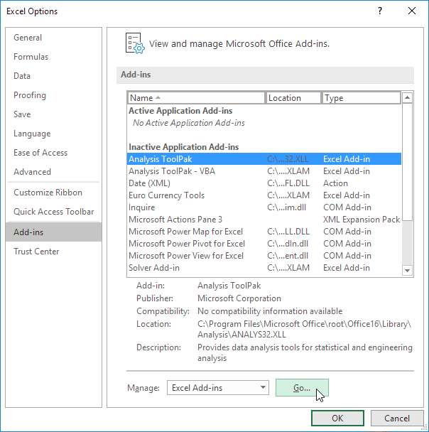

Image Source: Excel Easy

**ARITIFICIAL INTELLIGENCE IN EXCEL:**

An Impressive future in excel is the use of Artificial Intelligence (AI) to automate tasks and provide insights. AI can be used to perform a variety of tasks in excel such as

* Data entry and cleaning
* Data Analysis and visualization
* Report Generation
* Forecasting and prediction

Artificial Intelligence can also be used to develop new features and functionality for Excel. Here are few examples:

1.To develop a new feature and functionality for excel

AI could be used to develop new feature that automatically identifies and corrects errors in data.

AI could be used to develop a new feature that generates interactive reports that can be used to explore data in new ways.

2.To improve excel in future using AI

AI could be used to develop a tool that automatically identifies trends and patterns in data.

AI could be used to develop a tool that automatically generates hypotheses and tests them against the data.

This would make easier for users to gain insights from data if they are not experts in data analysis.

**Benefits of using AI in Excel:**

-Increased efficiency and productivity

-Improved accuracy

-Deeper insights

-More powerful features

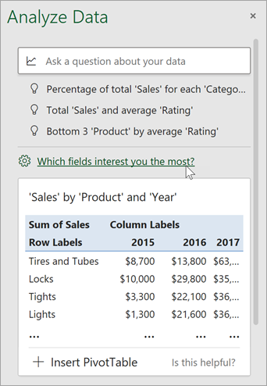 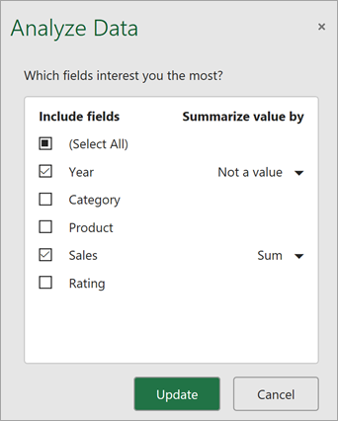 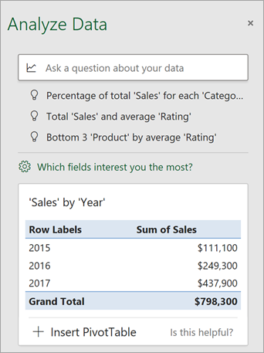

Artificial Intelligence has the potential to revolutionize the way excel is used by automating tasks, providing insights , and developing new features .

Artificial Intelligence can make Excel more efficient, accurate, and more powerful

**Source**: **https://support.microsoft.com/en-us/office/analyze-data-in-excel-3223aab8-f543-4fda-85ed-76bb0295ffc4?ui=en-us&rs=en-us&ad=us**

Analyze data works best with clean, tabular data**:**

